Exploring Income Inequality from Reddit Discussions

Regis University

**Abstract**

Income inequality is a very big issue that affects societies worldwide, influencing various aspects of life from education to healthcare. This paper explains public perceptions and discussions about income inequality for this data is collected from specific subreddits. By utilizing natural language processing and sentiment analysis techniques, we aim to identify prevalent themes and sentiments within these online communities. The results will contribute to a broader understanding of how income inequality is perceived and discussed in an online forum and providing insights.

**Introduction**

Income inequality is about how money is unevenly distributed among people in a community or country. Some people have a lot more money than others, and this difference can lead to various problems in society. These problems can affect things like access to good schools, healthcare, and opportunities to succeed. In our modern world, people use websites like Reddit to talk about these big issues. Reddit is a place where anyone can share their thoughts, ask questions, and discuss topics that matter to them. For our study, we chose to look at what people are saying about income inequality on Reddit. We focused on discussions happening in specific parts of Reddit where people talk about money and society. Our goal is to understand what most people are worried about when it comes to income inequality.

**Analysis**  
  
Gone through some posts to understand sentiment from Reddit, focusing on subreddits like r/Economics and r/BasicIncome, which frequently feature discussions on socio-economic topics.   
We used the Python Reddit API Wrapper (PRAW) to programmatically access Reddit data. After registering the application on Reddit's development portal, we were granted a Client ID and Client Secret, necessary for authenticating and accessing Reddit's resources.

We targeted the subreddit r/incomeinequality and r/BasicIncome, known for its engagement with socio-economic issues, to collect the top 100 posts of all time. The script extracted the title and body of each post, which were stored in a dictionary for further analysis. This method allowed us to gather a substantial amount of data while adhering to ethical standards and Reddit's API usage policies.

For Visual representations, including word clouds (refer Jupiter notebook attachment for code level) and bar charts, were created to illustrate the most frequently discussed terms and the sentiments associated with them.

1. word clouds

most frequent terms for r/incomeinequality  
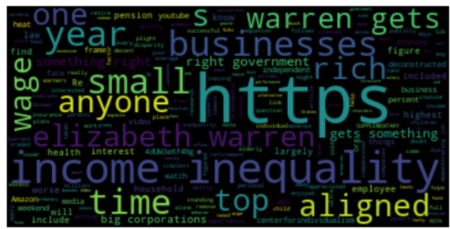

most frequent terms for r/BasicIncome

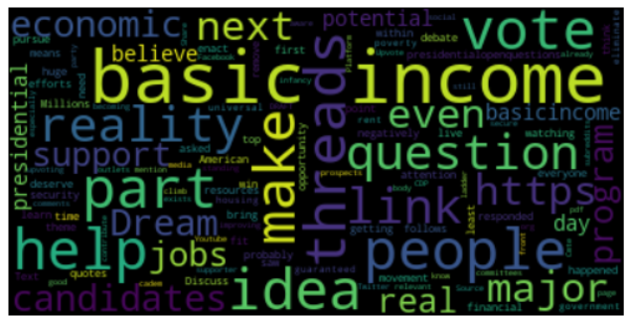

2.Bar graph

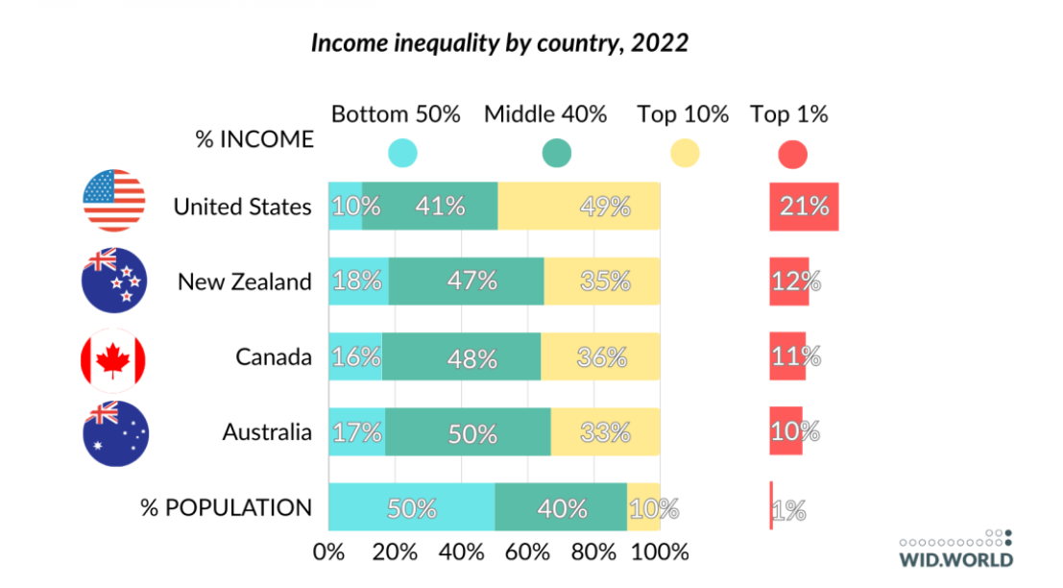In the United States, over 20% of all the money made goes to the richest 1% of people, which is more than in other nearby countries. In places like Australia, Canada, and New Zealand, the gap between rich and poor hasn't changed much. But in New Zealand, during the pandemic in 2020, this gap got bigger, though it has now gone back to how it was before.

3. Mind map   
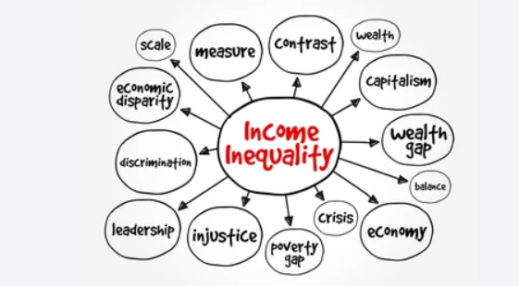

This picture shows a map of ideas about income inequality. It has words like "wealth gap," which means the difference in money between rich and poor people, and "poverty gap," which points to how hard it is for some to make ends meet. Words like "discrimination" suggest that not everyone is treated equally. "Crisis" hints at big problems related to money. Other words connect to the money system, like "capitalism" and "economy," and how people and rules, like "leadership" and "injustice," play a role. This map helps us see how all these ideas are linked to income inequality.

**Results**

In our study of online discussions about income inequality, we identified several recurring themes. These include minimum wage, which focuses on the earnings of the lowest-paid workers; wealth distribution, which examines how money and assets are spread among people; social mobility, concerning the opportunities people have to improve their financial status compared to previous generations; and government policies, which look at the laws and regulations that influence economic fairness and opportunity. Our sentiment analysis showed that the prevailing mood is quite negative, with many expressing dissatisfactions with current economic policies and conditions. This indicates a widespread desire for significant changes to make the economy fairer.

**Ethical Considerations**   
while conducting study for the paper, we took careful steps to ensure that all data was anonymized and that no personal information was extracted or displayed. By focusing on publicly available data and using it responsibly, we adhered to ethical standards to minimize privacy risks and bias.

1. Consent: People may not know their social media posts could be used for a study.  
2. Privacy: Even if posts are public, people might not want their information shared widely.  
3. Data Use: Posts should only be used for the study and not for making money or other reasons.  
4. Misinterpretation: It's important not to misunderstand the casual language people use online.  
5. Bias: The opinions in the study might not show what everyone thinks because not everyone uses social media the same way.  
6. Impact: The results of the study should be handled carefully to avoid affecting people negatively.

**Status of Common Good issue**

1. Current Status: Right now, income inequality means that a small group of people have a lot more money compared to many others who have much less.

2. Public Perception: Our look at social media shows that many people are talking about how income inequality is a big problem. They're worried because they see the gap between rich and poor getting bigger.

3. Experience of Inequality: Posts and comments suggest that people feel the cost of living is going up, but their pay isn't. They are also sharing stories about how hard it is to move up and earn more money.

4. Comparison Over Time: Compared to last year, more people are mentioning income inequality in their posts, which suggests it's becoming a bigger concern.

5. Sentiment Analysis Findings: The mood in the social media posts we looked at is mostly unhappy when it comes to money matters. People want things to change so that everyone has a fair chance.

**Limitations**  
Our study has a few limits because it looks at what Reddit users say. Reddit users are not always like most people, as they are often younger and from different places around the world. This means their opinions might not show what everyone thinks.

**Conclusion**

This study shows how analysing social media can help us understand what people think about big issues like income inequality. We found that many people are worried about the wealth gap and want changes in policies. For better results, future studies should look at more social media platforms and include a wider range of people. This will help us get a clearer view of what everyone thinks.

**Appendix**

Code snippets used for data collection and analysis  
Additional graphs and charts

**References**   
  
1. Research on topic : ( Youtube,website )  
 <https://www.youtube.com/watch?v=vSQjpTssoPw>  
https://inequality.stanford.edu/  
<https://www.imf.org/external/pubs/ft/sdn/2015/sdn1513.pdf>  
2.Sentiment on our topic - Reddit :  
<https://www.reddit.com/r/BasicIncome/comments/1b67so1/basic_income/> <https://www.reddit.com/r/Economics/comments/18j11it/why_economists_are_at_war_over_inequality/>  
3.Visualization plots over our topic :   
 <https://wid.world/news-article/2023-wid-update-north-america-and-oceania/>

4. Python Reddit API Wrapper (PRAW)